ATTACHMENT I

DMSA
Diretoria de Manutenção e
Suprimento de Armamento
PRELIMINARY TECHNICAL NOTE

NTP 002/2020-DMSA

ACQUISITION OF BALLISTIC VESTS LEVEL III-A OF THE MULTI-THREATH AND DISSIMULATED TYPE FOR THE CORPORATION

2020

Summary
1 – PROBLEM 4
2 - NORMATIVE ACTS THAT DISCIPLINE THE HIRING 16
3 - ALTERNATIVES 17
4 - SOLUTION 22
5 - AMOUNT 23
6 - SPECIFICATIONS 25
7 - HIRED'S OBLIGATIONS 30
8 - TECHNICAL QUALIFICATIONS 31
9 - INVENTORY 32
10 - TERM, LOCATION AND DELIVERY CONDITIONS 32
11 - TERM AND WARRANTY CONDITIONS 32
12 - REFERENCED MARKET VALUE 33
13 - MILITARY THAT WILL BE RESPONSIBLE FOR THE ELABORATION OF THE TERMS OF REFERENCE 34
14 - GESTOR E FISCAIS DO CONTRATO 34
15 - RELAÇÃO DE ANEXOS 34
16 - STATEMENT OF FEASIBILITY OR NOT OF CONTRACTING 35

1 – PROBLEM

  - Justification of the need for hiring
The State of Rio de Janeiro has been facing several challenges in the provision of public security to society over the last decades. The particularities of criminality in the region require the State to make a major investment in refitting and modernizing its police.
The Secretaria de Estado de Polícia Militar – SEPM, as a Public Administration organ and faithful to its guiding principles, must adopt the necessary measures to supply all the individual protection equipment available on the market and that are adequate to minimize the risk of death of its members, in their activities related to their missions constitutional requirements, as well as to inspect the correct use of such equipment.
The high rate of military police officers killed or injured when traveling from their homes to the service and vice versa, means that PMERJ has the initiative to distribute ballistic vests for individual protection to its members, which can be used covertly, both during service and during day off.
It is worth highlighting in the present study the uniqueness of the military police service in the State of Rio de Janeiro, where members of PMERJ are subject to the most varied forms of aggression by marginals of the Law, either through shots of firearms of different caliber or throwing explosive devices, both those manufactured by the war industry and those manufactured in an improvised way, and also threatening attacks with the use of sharp objects. Also, the vast arsenal of weapons of different caliber from the criminal factions represents a real risk to the military police in their daily work.
In 2016, the PMERJ's Committee on Dead and Injured carried out a confrontation study by type of service and concluded that most of the confrontations occurred during patrolling, that is, the military police were attacked by armed criminals during ostensible work, which aims precisely at the preservation of public order by preventing criminals from acting in society.

CONFLICT BY TYPE OF SERVICE
FIRST HALF OF 2016

Fontes: PMERJ/EMG/EGQ, PMERJ/EMG/EI.

According to studies of the PMERJ's Committee on the Dead and Injured, the number of officers who served at the institution, from 1994 to 2017, was approximately 90,000 military police officers, of whom 3,397 (3.77%) were killed and 15,236 (16, 93%) were injured, totaling 18,633 (20.7%) casualties in the period. When we consider only the metropolitan region (Rio de Janeiro, Niterói, São Gonçalo, Itaboraí and Baixada Fluminense), which brings together half of this number, about 45,000 military police, but which concentrates more than 95% of victimization, death rates, injuries and casualties have doubled, with 7% dead, 33% injured and 40% casualties in the past 24 years.

COMPARATIVE TABLE FOR THE LAST 24 YEARS
BETWEEN PMERJ AND MILITARY FORCES IN WARS
REFERÊNCIAS | PMERJ | FEB | EUA-1ª GM | EUA-2ª GM | EUA-COREIA |  | EUA-VIETINÃ | EUA-GOLFO PÉRSICO
EFETIVO QUE SERVIU NO PERÍODO | 90.000 | 25.334 | 4.734.991 | 16.112.566 | 5.720.000 |  | 9.200.000 | 2.225.000
MORTOS | 3.397 | 466 | 116.516 | 405.399 | 54.526 |  | 90.198 | 383
FERIDOS | 15.236 | 2.064 | 204.002 | 671.846 | 103.284 |  | 153.303 | 467
BAIXAS | 18.633 | 2.530 | 320.518 | 1.077.245 | 157.810 |  | 243.501 | 850
PERÍODOS EM DIAS | 8.720 | 239 | 730 | 1.395 | 1.125 |  | 4.135 | 210
PERÍODOS EM ANOS | 24  (1994-2017) | 0,65  (1944-1945) | 2  (1917-1918) | 3,82  (1941-1945) | 3,08  (1950-1953) |  | 11,33  (1964-1975) | 0,58  (1990-1991)
TAXA DE MORTOS | 3,77% | 1,84% | 2,46% | 2,52% | 0,95% |  | 0,98% | 0,02%
TAXA DE FERIDOS | 16,93% | 8,15% | 4,31% | 4,17% | 1,81% |  | 1,67% | 0,02%
TAXA DE BAIXA | 20,70% | 9,99% | 6,77% | 6,69% | 2,76% |  | 2,65% | 0,04%
TAXA DE MORTOS RELATIVA | 3,77% | 2,05 | 1,53 | 1,50 | 3,96 |  | 3,85 | 219,27
TAXA DE FERIDOS RELATIVA | 16,93% | 2,08 | 3,93 | 4,06 | 9,38 |  | 10,16 | 806,57
TAXA DE BAIXAS RELATIVA | 20,70% | 2,07 | 3,06 | 3,10 | 7,50 |  | 7,82 | 541,94
GM = GUERRA MUNDIAL
BAIXAS = MORTOS + FERIDOS
RELATIVAS = COMPARAÇÃO DA PMERJ COM AS DEMAIS
Fontes: PMERJ/EMG/EGQ, PMERJ/EMG/PM1, ISP, USA Congressional Research Service CRS Report RL 32492 e US Veteran Statistics.

BAIXAS NA PMERJ NA REGIÃO METROPOLITANA
EM 24 ANOS (1994-2017)
EFETIVO QUE SERVIU NO PERÍODO | 45.000
MORTOS | 3.397
FERIDOS | 15.236
BAIXAS | 18.633
PERÍODOS EM DIAS | 8.720
PERÍODOS EM ANOS | 24  (1994-2017)
TAXA DE MORTOS | 7,55%
TAXA DE FERIDOS | 33,86%
TAXA DE BAIXA | 41,41%
Fontes: PMERJ/EMG/EGQ, PMERJ/EMG/PM1, PMERJ/EMG/EI, ISP.

Therefore, it was found in the aforementioned study that it is more risky to work at PMERJ than to serve in the Brazilian Expeditionary Force or in the North American armed forces in any war of the 20th century, including the First and Second World Wars. As an extreme example, the chance of being injured here was more than eight hundred and six (806.57) times higher than serving in the Persian Gulf War (Kuwait).

BAIXAS NA PMERJ EM 24 ANOS
(1994-2017)

ANOS | MORTOS |  |  | FERIDOS |  |  | BAIXAS
ANOS | SERVIÇO | FOLGA | TOTAL | SERVIÇO | FOLGA | TOTAL | SERVIÇO | FOLGA | TOTAL
1994 | 14 | 213 | 227 | 20 | 491 | 511 | 34 | 704 | 738
1995 | 27 | 162 | 189 | 329 | 280 | 609 | 356 | 442 | 798
1996 | 38 | 137 | 175 | 338 | 339 | 677 | 376 | 476 | 852
1997 | 25 | 91 | 116 | 259 | 318 | 577 | 284 | 409 | 693
1998 | 20 | 102 | 122 | 245 | 272 | 517 | 265 | 374 | 639
1999 | 28 | 103 | 131 | 270 | 343 | 613 | 298 | 446 | 744
2000 | 20 | 118 | 138 | 235 | 364 | 599 | 255 | 482 | 737
2001 | 24 | 105 | 129 | 313 | 454 | 767 | 337 | 559 | 896
2002 | 33 | 119 | 152 | 373 | 412 | 785 | 406 | 531 | 937
2003 | 46 | 131 | 177 | 493 | 362 | 855 | 539 | 493 | 1032
2004 | 50 | 113 | 163 | 394 | 358 | 752 | 444 | 471 | 915
2005 | 25 | 113 | 138 | 356 | 380 | 736 | 381 | 493 | 874
2006 | 29 | 124 | 153 | 337 | 363 | 700 | 366 | 487 | 853
2007 | 25 | 105 | 130 | 330 | 320 | 650 | 355 | 425 | 780
2008 | 22 | 90 | 112 | 269 | 271 | 540 | 291 | 361 | 652
2009 | 26 | 110 | 136 | 279 | 284 | 563 | 305 | 394 | 699
2010 | 21 | 107 | 128 | 237 | 267 | 504 | 258 | 374 | 632
2011 | 9 | 99 | 108 | 199 | 224 | 423 | 208 | 323 | 531
2012 | 15 | 100 | 115 | 212 | 304 | 516 | 227 | 404 | 631
2013 | 17 | 100 | 117 | 298 | 335 | 633 | 315 | 435 | 750
2014 | 17 | 95 | 112 | 270 | 303 | 573 | 287 | 398 | 685
2015 | 25 | 94 | 119 | 305 | 330 | 635 | 330 | 424 | 754
2016 | 41 | 106 | 147 | 423 | 294 | 717 | 464 | 400 | 864
2017 | 35 | 128 | 163 | 464 | 320 | 784 | 499 | 448 | 947
TOTAL | 632 | 2765 | 3397 | 7248 | 7988 | 15236 | 7880 | 10753 | 18633
Fontes: EMG/EGQ, EMG/PM1, EMG/EI E ISP.
Below we can see the graphs that show the evolution of deaths and injuries during the 24 years:

It is true that the concept of risk is inherent in the military police function. However, there is a way to mitigate it. The adequate supply of personal protective equipment, in this case, the multi-threat ballistic protection vests, is one of the ways to minimize such risks and, consequently, increase the security of police officers in their daily tasks.
According to UN resolution no. 34/169, of December 17, 1979 (Code of Conduct for Law Enforcement Officials), in its general provisions, it is the State's obligation to provide the police with personal protective equipment (PPE) and collective protection equipment (EPC), see the text:
“(...) For the same purpose, it should also be possible to provide the police with defensive equipment, such as shields, visors, anti-ballistic vests and armored vehicles, in order to reduce the need to use any type of weapons.”
The graphs below show the Operational Units and the number of armed clashes between January 2016 and December 2017: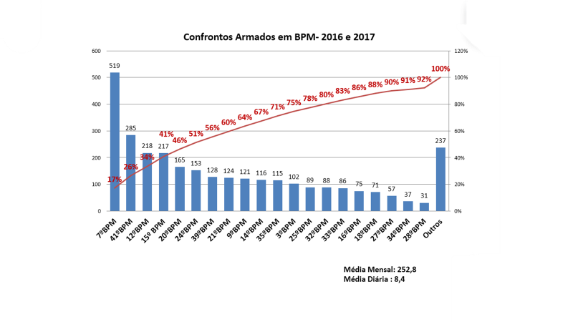
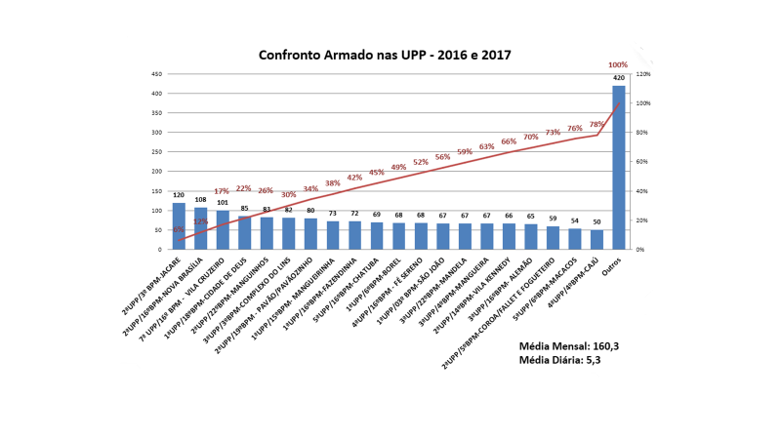

In these terms, it appears that the State of Rio de Janeiro is experiencing a real situation of daily confrontations between the forces of Public Security and marginals of the law. Therefore, police victimization represents, in the medium and long term, a considerable damage to public coffers. We can verify this data through the study carried out by PMERJ's Committee on the Dead and Injured, based on the year 2017.
Police victimization, cost the State of Rio de Janeiro, just in 2017, approximately R$ 43,723,493.60, of which R $ 28,764,444.78 with psychiatric treatment, R $ 3,494,986.58 with sick people injured by projectiles of firearms in service, R $ 2,164,062.29 with deaths in service and R $ 9,300,000.00 with life insurance, without taking into account hospital medical expenses.
It is entirely possible to deduce that, taking into account the cost of police victimization for the year 2017, the long-term losses will become astronomical.
The table below shows the cost of the police discharge relative to the time he still had to contribute to his services:
TABELA CUSTO DA BAIXA POLICIAL
Nº | DATA MORTE EM SERVIÇO | GRD | RG | TEMPO RESTANTE DE SERVIÇO | MÉDIA  REMUNERAÇÃO | GASTO POR ANO | VALOR GASTO POR TEMPO RESTANTE DE SERVIÇO
1 | 01/01/2017 | CB | 93.772 | 24 | R$ 4.057,13 | R$ 54.095,07 | R$ 1.298.281,60
2 | 12/01/2017 | CB | 96.078 | 25 | R$ 4.057,13 | R$ 54.095,07 | R$ 1.352.376,67
3 | 13/01/2017 | 1º SGT | 62.120 | 10 | R$ 6.933,64 | R$ 92.448,53 | R$ 924.485,33
4 | 30/01/2017 | 2º TEN | 75.517 | 14 | R$ 7.257,46 | R$ 96.766,13 | R$ 1.354.725,87
5 | 07/02/2017 | 3º SGT | 85.085 | 21 | R$ 5.301,84 | R$ 70.691,20 | R$ 1.484.515,20
6 | 22/02/2017 | CB | 104.798 | 28 | R$ 4.057,13 | R$ 54.095,07 | R$ 1.514.661,87
7 | 29/02/2017 | CB | 101.544 | 27 | R$ 4.057,13 | R$ 54.095,07 | R$ 1.460.566,80
8 | 04/02/2017 | CB | 92.204 | 24 | R$ 4.057,13 | R$ 54.095,07 | R$ 1.298.281,60
9 | 04/02/2017 | 1º SGT | 61.649 | 10 | R$ 6.933,64 | R$ 92.448,53 | R$ 924.485,33
Gasto por ano
A calculation was made taking into account the salary of the police officer (stopped at the time of death and without taking into account the promotions) multiplied by 13 (as long as the 13th salary) and adding up to 1/3 of vacation. Thus: (R $ 4,057.13 * 13) + (R $ 4,057.13 * 1/3) = R $ 54,095.07;
Remaining spend
A calculation was made taking into account the policeman's annual salary multiplied by the remaining service time. Thus: R $ 54,095.07 * 24 = R $ 1,298,281.60

In the graph below, the percentage of police officers who die related to the time remaining for service is very transparent:

In view of the countless confrontations between the Security Forces and marginals of the law, it is necessary to use multi-threat ballistic protection vests.
It is well known that the Military Police of the State of Rio de Janeiro faces a unique scenario of urban warfare that can be classified as: War of socioeconomic, irregular, 4th generation, asymmetric, guerrilla, psychological and local war.
“Asymmetric war: it consists in giving tacitly to one of the belligerent sides the absolute right to use all means of action, however vile and criminal, while exploring as a strategic trick the moral and legal commitments that tie the opponent's hands. " (Glaring differences, Olavo de Carvalho, O Globo, May 15, 2004).
Currently, in the State of Rio de Janeiro, an analogy can be drawn between asymmetric war and the confrontation between the police and the bandits. The criminal does not have to worry about laws or moral standards of conduct in his actions, whereas law enforcement officers must base their actions on moral and legal commitments.
According to information obtained from the First Section of the General Staff of the PMERJ (EMG-PM1), the active force of the Corporation is 44,643 (forty-four thousand six hundred and forty-three) Military Police, data for the month of March 2020 , and the PMERJ staff in conditions to guard such Ballistic Vests, is around 35,399 (thirty five thousand three hundred and ninety nine) Military Police.
Because of the presented demand, and in order to resolve the issue, it is necessary to purchase individual protective equipment, like a multi-threat concealed ballistic vest in accordance with the technical specifications indicated in this NTP to be made available for use by the members of the corporation and according to the rules established for granting the precautions.
Taking into account the purchase of 14,275 (fourteen thousand two hundred and seventy-five) level III ballistic vests carried out by GIF, the need to purchase 25,000 (twenty-five thousand) ballistic vests within the scope of the Secretaria de Estado de Polícia Militar (SEPM) aiming to supply the basic security needs of military police.

  - Planning tools
Initially, it is important to highlight the decree nº 45, of December 20, 2018, published in the Bol da PM nº 190, of December 28, 2018, which created the Diretoria de Manutenção e Suprimento de Armamento (DMSA). The aforementioned decree defines that the DMSA's mission is to provide and provide the necessary resources for the logistical arms class, while also having the mission of cataloging and standardizing the armament used in SEPM.
As a planning tool, it is worth mentioning what was agreed in the Termo de Ajuste de Conduta (TAC) between the Estado do Rio de Janeiro and the Ministério Público do Estado do Rio de Janeiro, through the records of administrative process No. E-14 / 001.023.797 / 2015 and public Civil Inquiry No. 2013.00060913, in Clause Fif (On the health and safety of the military police), it says:
"Item 5.3 The State will discipline the use of Collective and Individual Protection Equipment, according to the different activities performed by professionals in the corporation, within one year.
item 5.4 - The State will make available, in an adequate amount, equipment for operational use and individual protection that include differences in gender and physique, guaranteeing its permanent replacement, considering the wear and expiration dates.
item 5.5 - To all police officers in effective exercise in the end activity, it shall be made available, within a period of 6 (six) years:
Item 5.5.1 Individual ballistic protection vest, with the Military Police regulating its use and conservation
. ”
Still on the TAC, in the ninth clause (On the structure of the police units) it says:
"Item 9.5 - The State, within a year, will seek the standardization of the quantity and periodicity of the supply of materials for continuous use by the Military Police Units and, being technically advisable, it will seek the standardization of its quality respecting the peculiarities of the units that have specific needs. ”
Within the SEPM Strategic Plan 2020-2024, the Policia Militar do Estado do Rio de Janeiro, has among its strategic objectives the following: “item 3 - Optimize operational capacity; item4 - Renew the logistical and structural capacity of the various organizations; and item 6 - Improve and value the effective military police. ”
Furthermore, a State Secretariat of the Military Police, in order to combat, modernize and standardize the company's armament, created a SEPM ARMS STANDARDIZATION COMMISSION, PM Bol No. 115, of June 27, 2019, having a due attention to human resources, material and financial resources available, as well as improving the quality of armaments and services offered to society.
  - Intended results of meeting demand
In face this unique scenario, it is essential that the ballistic vests to be purchased are concealed, multi-threat, level III-A ballistic protection, classified according to NIJ STD 0101.04 or NIJ STD 0101.06 for firearm projectiles and NIJ 0115.00 Level 1 for sharp objects ("Spike" and knife). They must also have protection against fragments of explosive devices with the certificate in accordance with the international standard STANAG 2920 (F5 V50 FSP 1.1g> 590 m / s, or higher).
Considering the working hours of the military police in their operational field, it is desirable that the vests have low weight and high flexibility, in order to guarantee greater efficiency and the greatest possible comfort when in use and without compromising their effectiveness.

2 - NORMATIVE ACTS THAT DISCIPLINE THE HIRING

Considering the need to point out the regulations that govern the contracting of the object of this preliminary study, the list below follows: Constituição da República Federativa do Brasil de 1988 – CRFB/88;
- Law No. 8,666, of June 21, 1993 - Regulates art. 37, item XXI, of Constituição Federal, institutes rules for public tenders and contracts and takes other measures;
- Law No. 10,826, of December 22, 2003 - Disarmament Statute - Provides for the registration, possession and sale of firearms and ammunition, on the National Weapons System - Sinarm, defines crimes and takes other measures;
- Decree No. 9,607, of December 12, 2018 - Institutes the National Policy for the Export and Import of Defense Products;
- Decree No. 10,030, of September 30, 2019 - Controlled Products Regulation.
- Resolution 34/169, 12/17/1979 - Code of Conduct for Employees responsible for applying the law;
- Interministerial Ordinance No. 4,226 of December 31, 2010 - establishes guidelines on the use of force by public security agents;
- Normative Instruction No. 5, of May 25, 2017 (In 05 / MPDG / 2017) - Provides for rules and guidelines for the procedure for contracting services under the indirect execution regime within the Federal Public Administration;
- 2.8 Annex a Ordinance PMERJ nº 774, of May 23, 2017 - Bol of PM nº 117 - 28 Jun 17 p. 53 to 70 - Regulations for the internal phase of bidding processes in the Corporation (PMERJ);
- Statement n.º 39 – PGE RJ (Procuradoria Geral do Estado do Rio de Janeiro) - Technical qualification of the bidder;
- Statement n.º 35 – PGE RJ (Procuradoria Geral do Estado do Rio de Janeiro) - Public Hearing in bidings;
- International standard NIJ Standard 0115.00;
- International standard NIJ Standard 0101.04;
- International standard NIJ Standard 0101.06;
- International standard STANAG 2920.

3 - ALTERNATIVES

Considering that this topic should indicate the existing solution proposals to meet the demand, the need to meet the acquisition of individual protection material that contemplates gender differences and physical complexion is evident, guaranteeing its permanent replacement, considering the wear and tear and validity periods of individual ballistic protection vest for the calibers often encountered with criminals in the State of Rio de Janeiro.
This time, the following will be presented:
3.1. Production by SEPM of the desired ballistic vest model.
The manufacture of ballistic vests, level III-A, requires the purchase of all necessary supplies from the respective manufacturers, such as aramid plates or aramid and polyethylene compound, fabrics for the panels, fabrics for the covers, Velcro, materials for printing descriptions of the vests, etc.
It also requires specialization of personnel for the activity, which requires time and financial resources.
Such situations have a negative impact on the cost-benefit binomial in addition to adding unnecessary responsibility to the institution for the current moment. It is worth mentioning that the national and international specialized market has an indisputable "Know-how" in the manufacture of ballistic vests.
3.2 Acquisition of ballistic vests level III-A - Multi-threat - Dissimulated
Bulletproof vest or ballistic vest (which is the correct technical term to identify them) are special garments that protect users from projectiles or debris from military artifacts (e.g. grenades or other explosives). They are usually made of Kevlar, an aramid fiber, a synthetic material similar to nylon, light and flexible but five times more resistant than steel.
The American scientist Stephanie Kwolek of Dupont, in 1965, in the search for a material with the thermal resistance of asbestos and rigidity of fiberglass, ended up discovering a new polymer. As the projectiles are made of lead (often coated with a harder metal alloy), the speed they reach when launched are fatal. With Kevlar, it is possible to obtain protection for these artifacts.
Characteristics of Kevlar: insoluble, immune to chemical attack, fire resistant, flexible and light.
It is not only on vests that Kevlar material is applied. It is also used in coatings for aircraft engines to prevent a possible explosion in the turbine or compressor from damaging them.
Ballistic vests are classified by their level of protection according to NIJ - National Institute of Justice standards. These standards, determined by the United States, are followed by several countries. See the protection levels:
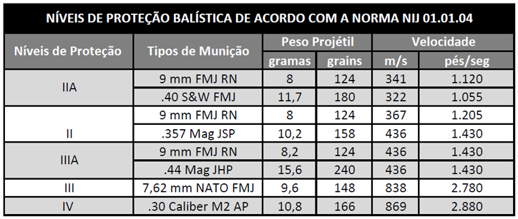
Level III-A ballistic protection vests are impact resistant with average speeds of 427 meters per second. Weapons such as 9 mm pistols and Magnum .44 are among those that produce impacts of this nature according to the protection levels of Standard N IJ STD 0101.04 and N IJ STD 0101.06.
Disguised models gain versatility compared to ostensive / operational models since they can be used by the operational service, ostensive policing, by reserved / hidden service, for use in commuting to work, for use in personal protection, etc.
The Ballistic vest, concealed, level III-A, Multi-threat (level I - knife and "spike"), protects agents who are subject to the most varied forms of aggression by marginals of the law, whether through firearm shots. of various calibers, or throwing explosive devices, both those manufactured by the military industry and those manufactured in an improvised way, and also threatening attacks perpetrated with the use of sharp objects, representing a real risk to the military police in their daily work.
National manufacturers, so far, have not provided satisfactory information on the availability of sale / purchase of ballistic vests, concealed, level III-A protection, Multi-threat (level I - knife and spike), to meet SEPM's demand, as contacts by email (ANNEX I).
Below, in order to corroborate with the present study, three international companies that presented models that meet the corporation's demand.

3.2.1 Manufacturer BONOWI International Police-Equipment GmbH - Model “I-NIGMA 1”

I-NIGMA 1
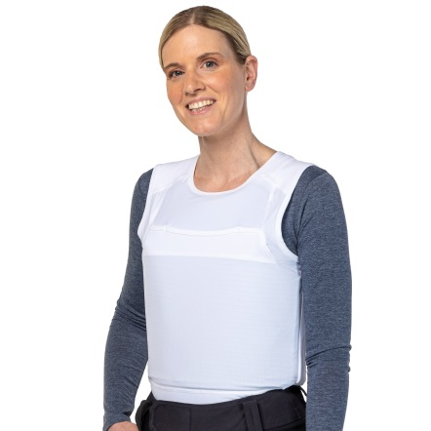

Level IIIA ballistic panels:
- • Composition of at least 80% aramid;
- • NIJ 0101.04;
- • NIJ 0115.00 (for Spike and knife level I);
- • Maximum weight per square meter ≤ 5,380.

T-shirt (cover)
- • Made of resistant material with antibacterial / anti odor treatment;
- • Able to pack the boards and panels separately in a fair and comfortable way.

The basis of this series of ballistic vests is a functional t-shirt, developed in cooperation with the company ODLO. The shirt fits tightly to the body and is highly flexible. The combination of the T-shirt with the soft SK 1+ or the "Columbus package" offers unprecedented wearing comfort, even for longer periods.
In special policing situations, the shirt, usually used as SK 1+, can be upgraded with VPAM 6 (950 g) or VPAM 9 (2300 g) ballistic plates. The support system ensures that the sliding plates are comfortable. The adjustment of the plates provides stable fixation to the body, even during extreme movements and without creating pressure as a result.
Website: https://www.bonowi.com/en/products/ballistic-protection


3.2.2 Manufacturer MIGUEL CABALLERO - Model “Tank Top”

The company is responsible for designing, developing and providing solutions for specialized personal protection, through innovative clothing and products, created with the aim of preserving the lives of consumers from possible types of ballistic threats, among other ways.

TANK TOP

• Protection level IIIA according to NIJ 0101.06;
• Protection level I anti spike according to NIJ 0115;
• T-shirt with level IIIA ballistic panels and plate holder for level III;
• Able to stop the following ammunition:
• .357 SIG FMJ FN
• .44 MAGNUM SJHP

- Available colors :
  - Black
  - White

- • External lining produced by resistant material that provides flexibility to the user;
- • Internal lining in 3D mesh providing better comfort and better perspiration;
- • Zippered sides providing the user with agility when dressing;
- • Internal thermoregulatory material, normalizes and maintains the appropriate temperature for the body;
- • Unified ballistic and anti-spike panels (front and back) flexible;
- • The model presented meets the criteria established by the international standard STANAG 2920;
- • 05 (five) year ballistic and anti-spike panels warranty;
- • 01 (one) year cover warranty;
• Available sizes, S to XL (can be made to measure, thus adding value).
Website: https://miguelcaballero.com/gold/

3.2.3 Manufacturer “MKU Limited”


CONCEALABLE VESTS WITH BALLISTIC PLATES - JCO IIA
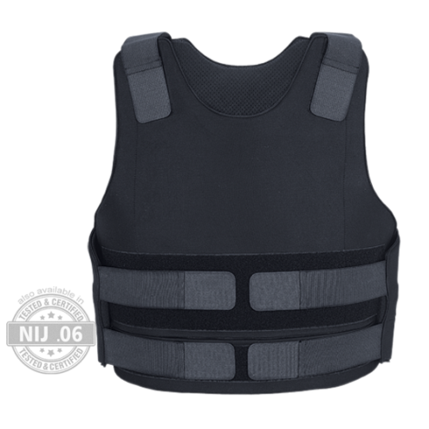

Level IIIA ballistic panels:
• NIJ 0101.04;
• NIJ 0115.00 (for Spike and knife level I);
• Front, back and side protection.
T-shirt (cover)
• Made of resistant material with antibacterial / anti odor treatment;
• Able to pack the plates and panels separately tight.
Website: https://www.mku.com/en/products/JCO-II-A

4 - SOLUTION
It is imperative that the ballistic vests meet are specified in this NTP. Therefore, as in the contacts, by email (ANNEX I), made with the main manufacturers of collections in the national market, satisfactory answers are not allowed on products that fully meet the specifications, there is a need to carry out an international bid. for an on-screen acquisition, in accordance with articles 31 and 32 of Ordinance nº 18 - D LOG, of December 19, 2006 of the Army Command.
Art. 31. Bulletproof vests may be imported:
I - of permitted or restricted use for public security organs, members of the judiciary and the public ministry of the union, the States and the Federal District, and members of the public security organs and the armed forces; and
II - of permitted use for private companies specialized in surveillance and transportation of valuables.
Art. 32. The importation of bulletproof vests, on an exceptional basis, will only be authorized when the national industry is unable to meet the technical specification and / or desired demand.
Sole paragraph: imports of used or reconditioned vests will not be authorized.
Therefore, it can be inferred that the DISSIMULATED, MULTI-THREAT BALLISTIC VEST, LEVEL III-A BALLISTIC PROTECTION, classified according to NIJ STD 0101.04 or NIJ STD 0101.06 for firearm projectiles and NIJ 0115.00 Level 1 for sharp objects (“ Spike ”and knife) and for protection against fragments of explosive devices with the certificate according to the international standard STANAG 2920 (F5 V50 FSP 1.1g> 590 m / s, or higher), is the best solution for contracting. And for a better explanation, here are some advantages and disadvantages:
ADVANTAGES | DISADVANTAGES
Less weight than the current vests used in the corporation. | It was not possible to find a manufacturer in the national territory.
High flexibility. | Need for international bidding.
Multi-threat protection: ballistic, piercing and piercing-cutting.
Concealed increases the range of possibilities for use by the police and greater discretion.
Increased validity and warranty

5 - AMOUNT

5.1 Calculation methodology
According to information obtained from the First Section of the General Staff of SEPM (EMG-PM1), the active force of the Corporation is 44,643 (forty-four thousand six hundred and forty-three) Military Police, data for February 2019 , and the SEPM staff in conditions (“Ready”) to take care of such Ballistic Vests, is around 35,399 (thirty-five thousand three hundred and ninety-nine) Military Police.
In view of the presented demand and in order to resolve the issue, it is necessary to purchase individual protective equipment, like a multi-threat concealed ballistic vest in accordance with the technical specifications indicated in this NTP to be made available for use by the members of the corporation and according to standards
Taking into account the purchase of 14,275 (fourteen thousand two hundred and seventy-five) level III ballistic vests carried out by the Gabinete de Intervenção Federal (GIF), there is a need to purchase 25,000 (twenty-five thousand) ballistic vests in the within the scope of the Secretaria de Estado de Polícia Militar (SEPM) aiming to supply the basic security needs of military police, with the addition of a technical reserve of approximately 20% (twenty percent).
The quantity specified by size will only be defined after the presentation by the contractor of the sizes practiced by the latter, among the standards of size XS to XL, according to the drawing and table below:

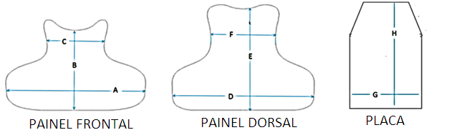

 | A | B | C | D | E | F | G | H
MÍNIMO  (mm) | 530 | 340 | 210 | 540 | 435 | 245 | 280 | 180
MÁXIMO  (mm) | 700 | 410 | 320 | 680 | 500 | 330 | 360 | 290

The winner must provide the technical drawings of the vests in all dimensions to support the future decision. The panels should have protection on the front, back and side, including the lower abdomen, lumbar and the side closest to the armpit, without considerably compromising the user's mobility and comfort. Therefore, the quantities by size will only be established after defining the winner for the purchase of the ballistic vests.

6 - SPECIFICATIONS

6.1 General features
6.1.1 Protection Level
6.1.1.1. Protection Level III-A according to the protection levels of NIJ Standard 0101.04 or NIJ Standard 0101.06;
6.1.1.2. Level 1 according to NIJ Standard 0115.00 protection levels, Spike threats, Knife P1 and Knife S1;
6.1.1.3. Meet the criteria established in the international standard STANAG 2920 (F5 V50 FSP 1.1g> 590 m / s, or higher).
6.2 Specific features:
6.2.1 Ballistic Panel
6.2.1.1 Panels (front and back) arranged in successive layers. Made of light and flexible material (minimum 80% aramid) in order to achieve the desired level of protection, comfort and ergonomics, to be used in chest - abdominal protection, another in the dorsal region, as well as effective lateral protection. That is, the ballistic panel must have the largest possible area of ​​protection of the trunk including the sides, with the best mobility for the user.
6.2.1.2 The sides of the front panel (side flaps) must overlap the side of the dorsal panel in order to effect lateral protection.
6.2.1.3 The format and dimensions of the panels must be presented by the contractor in order to verify the standardization of the sizes and the respective quantities, following the drawings and the table below in the distribution of the measurements according to the different sizes (from XS to XL):

 | A | B | C | D | E | F | G | H
MÍNIMO  (mm) | 530 | 340 | 210 | 540 | 435 | 245 | 280 | 180
MÁXIMO  (mm) | 700 | 410 | 320 | 680 | 500 | 330 | 360 | 290

6.2.1.4 The panels must have protection on the front, back and side, including the lower abdomen, lumbar and the one closest to the armpit, without significantly compromising the user's mobility and comfort.
6.2.1.5 Serial numbering must be included for each 8 layers of the panel.
6.2.1.6 The seam line, which holds the layers of each panel together, must have characteristics necessary for the joining of the blades at the edge of the panel and must be bent after sewing or technology of the same or higher quality applied to prevent the fraying of the blades. Each panel is surrounded by a wrapper conditioned to its shape and dimensions, made of waterproofed polyamide fabric, with previously edged edges or technology of equal or superior quality that prevents its fraying.
6.2.2 Ballistic panel finish
6.2.2.1 On its external face, the ballistic panels must have the permanent inscription “FRONT PANEL”, “DORSAL PANEL” or “SIDE PANEL”, as the case may be, as well as the inscription “IMPACT SURFACE”.
6.2.2.2 The panels must have permanent identification instruments in Portuguese as: ballistic protection level according to NIJ 0101.04 or NIJ 0101.06, NIJ 0115.00 and STANAG 2920, date of manufacture in MM / AA format, valid in MM / AA format, warranty in number of years, serial number, manufacturing batch, manufacturer's identification, size, handling instructions, warning of correct use and validity.
6.2.2.3 Regarding the coating, all ballistic panels must be covered by an impermeable wrapper made of hydro-repellent or similar fabric, which is resistant to liquids, humidity, rain water and sweat from the user's body and other factors that may cause the compromise of ballistic protection.

6.2.3 Ballistic panels weight
Mass per unit area
(g/m₂)
≤ 5.380

6.2.4. Ballistic Panels Flexibility
6.2.4.1Responsible for the verification
Instituto de Pesquisas Tecnológicas Technical´s – IPT
6.2.4.2. Testing procedures
The samples will be sent to the Instituto de Pesquisas Tecnológicas- IPT, free of charge to the bidder, in order to check the flexibility standards required in this technical note.
6.2.4.3. Nível de flexibilidade desejável
Measurement location | Bending  angle (º)
Front | ≥ 30
Back | ≥ 75

6.2.5 Certification
6.2.5.1 Ballistic vests must have certification and proof in accredited national or international laboratory and certified by NIJ 0101.04 (Level III-A) or NIJ 0101.06 (Level III-A), NIJ STD 0115.00 (Level I).
6.2.5.2 Although certification is not required, the vests will be tested for protection against fragments of explosive devices in accordance with STANAG 2920 (F5 V50 FSP 1.1g> 590 m / s, or higher), passing the trauma and ballistic limit tests, in accordance with the methodology contained in the said rules and establishing its legal adequacy to Art. 17, § 2, of Federal Decree nº 9493/18.

6.2.6 Warranty and Shelf life
Minimum guarantee of 72 (seventy-two) months. It adds that in relation to the life span of the vests, it is desirable that the product has a shelf life of 10 (ten) years or more. Such term finds its reasonableness in the useful life of a “top of the line” equipment, considering the savings in the acquisition, since due to the specificity of the equipment, it is not convenient to use obsolete material with similar cost and that this indication can be changed due to its proper use and correct storage.6.2.7. Apresentação de amostras
6.2.7.1. After the respective qualification of the best ranked competitor, he must present 01 (one) model of ballistic vest of each size (S, M, L and XL), of each segment (male and female), if not unisex, totaling 08 (eight) ballistic vests.
6.2.7.2. The winning bidder must also submit the reports on the fabric of the protective covers.
6.2.7.3. The respective samples must be accompanied by the respective technical reports and cannot be part of the total amount of the acquisition.
6.2.7.4. Ballistic panel finish
6.2.7.4.1. On its external face, the ballistic panels must have the permanent inscription “FRONT PANEL”, “DORSAL PANEL” or “SIDE PANEL”, as the case may be, as well as the inscription “IMPACT SURFACE”.
6.2.7.4.2. The panels must have permanent identification instruments in Portuguese as: ballistic protection level according to NIJ 0101.04 or NIJ standard 0101.06, NIJ 0115.00 and STANAG 2920, date of manufacture in MM / AA format, valid in MM / AA format, warranty on quantity of anso, serial number, batch of manufacture, identification of the manufacturer, size, handling instructions, warning on the correct use and validity.
6.2.7.4.3. Regarding the coating, all ballistic panels must be covered by an impermeable wrapper made of water-repellent or similar fabric, which is resistant to liquids, humidity, rain water and sweat from the user's body and other factors that may cause the compromise of ballistic protection.
6.2.7.4.4. A label must be affixed to each of the internal layers, front and back, on the respective surfaces that must face the contact side with the user's body.

6.2.8. Capas
6.2.8.1. The making of the covers must meet the highest quality standards of the textile industry and offer adequate ergonomics to the human body so that when used in ostensive policing, the body's protection areas are not compromised, taking into account factors such as prolonged use of the material and mobility for the Military Police;
6.2.8.2. All ballistic vests must be supplied with 02 (two) dissimulated covers (shirt type), 01 (one) in white and 01 (one) in black, taking into account the male and female types;
6.2.8.3. The inner face must be made with the same fabric as the outer face or in a fabric that allows moisture dispersion and with antibacterial treatment.
6.2.8.4. Considering the concealed use of the vests, the displacement and itinerary dynamics of the Military Police, the height and side adjustments to fit the body should be made backwards, with a rounded end at their ends.
6.2.8.5. The adjustment mechanisms must allow the user to fix the equipment without the aid of third parties.
6.2.8.6. The hidden covers must have a receptacle to accommodate the ballistic plates that allow the vest to be transformed into Level III, with a size of 30cm (height) x 25cm (width).

6.2.9 Radio frequency identification
6.2.9.1 Passive electronic radio frequency identification device, of the Radio-Frequency Identification (RFID) chip type, which meets the 900Hz frequency, which allows the reading of codes to identify the numbering of the vest, by means of a scanner, in the event of markings ( confidential and security) have been suppressed by any means;
6.2.9.2 the information and / or details specific to the location of the RFID will be treated in a contract with a confidentiality clause between the manufacturer and DMSA;
6.2.9.3 in order to facilitate the reading of confidential information, a scanner equipment compatible with the reading of the RFId chip must be provided by the manufacturer, for each batch of 500 (five hundred) vests, which it supplies, only and exclusively for this purpose.

7 - HIRED'S OBLIGATIONS

- The contractor must observe the provisions of art. 3, § 1 and Art. 4, § 1, of State Law 8.186 / 18, which instituted the state policy for the control of firearms, their parts, and ammunition ;
- Deliver the goods, in the quantity, quality, location and terms specified in this note;
- Deliver the object of the contract without any burden to the CONTRACTING PARTY, being included in the payment amount all and any expenses, such as taxes, freight, insurance and unloading of the goods;
- Keep in stock a minimum of goods necessary for the performance of the object of the contract;
- Communicate to the contract supervisor, in writing and as soon as a problem or the impossibility of executing the delivery is verified, as well as any contractual obligation, for the adoption of the appropriate measures;
- Repair, correct, remove, reconstruct or replace, in whole or in part and at your expense, the assets that are the subject of the contract in which there are defects, defects or inaccuracies resulting from irregular execution or from the supply of inappropriate or non-conforming materials;
- Indemnify any and all personal or material damages and losses that may arise, directly or indirectly, from the exercise of its activities or be caused by its agents to the CONTRACTING PARTY or third parties.
- Call the CONTRACTING PARTY, free of charge, for any Recall programs offered by the supplier, referring to the object of the future contract.

8 - TECHNICAL QUALIFICATIONS

8.1 The bidder must prove technical qualification, by means of Technical Capacity Certificates, provided by Legal Entities of Public or Private Law, who demonstrate that they have provided services in society similar in characteristics, quantities and terms similar to the object of this bidding (BALLISTIC LEVEL VEST III-A OF THE MULTI-MADE AND DISSIMULATED TYPE).
8.1.1 It will be accepted a certificate that proves the technical capacity of at least 50% (fifty percent) in relation to the quantitative of the most relevant items, in compliance with Statement 39 - PGE RJ (Procuradoria Geral do Estado do Rio de Janeiro) - Technical qualification of the bidder;
8.1.2 Said proof may be made by adding the quantities performed in as many contracts as the Bidder has;
8.1.3 Declaration that the bidder has or meets the conditions to present, upon delivery of the contract object resulting from this bidding, a document proving regularity before the Ministry of Defense - Brazilian Army, for the sale of controlled products related to this event, according to the Decree Federal No. 10,030, of September 30, 2019 - Regulations for the Inspection of Controlled Products.
8.2 In the qualification phase, a report issued by a test bank or independent laboratory must be presented by the supplier company, containing tests that prove the equipment's capacity, according to the needs of the State Secretariat of Military Police (SEPM) - Military Police of the State of Rio de Janeiro (PMERJ);

9 - INVENTORY

In a survey carried out by the 4th Section of EMG in charge of SEPM (process SEI-350096/000402/2020 - CI SEPM / PM4 SEI Nº 6731 and 6856), it was found that SEPM currently has a total of 17,514 BALLISTIC VESTS III-A LEVEL of Manufacturer INBRATERRESTRE Ind. Com. De mat. Seg. Ltda, distributed in police units, with expiration between April and September 2021.

10 - TERM, LOCATION AND DELIVERY CONDITIONS

- Delivery time: The delivery of the military equipment must occur within 120 (one hundred and twenty) days after the issue of the Commitment Note.
- The delivery of the products will be monitored and supervised by the Manager and inspectors, at the contractor's expense, in the condition of representatives, who shall carry out the prior verification at the factory and subsequently the definitive verification of the material and attest the expense documents, when proven to faithful and correct delivery for payment purposes;
- The material must be delivered at the Depósito Central de Munições da PMERJ (DCMun), located at Avenida Feliciano Sodré nº 190 / Niterói - Rio de Janeiro. CEP-24.030-012;
- The receipt of the material will be conditioned to the observance of its technical specifications, packaging, being the verification of the CONTRACTING PARTY representative;
- The contract must be executed for a global price and in a single delivery.

11 - TERM AND WARRANTY CONDITIONS

- Minimum warranty of 72 (seventy-two) months. If the term provided by the manufacturer is more advantageous for the Administration, the guarantee offered by the material manufacturer prevails, starting to run after the end of the term of the legal guarantee referred to in Law n ° 8.078 / 90, which starts from of definitive receipt, without charge to the Military Police of the State of Rio de Janeiro.
- It adds that in relation to the life span of the vests, it is desirable that the product has a validity of 10 (ten) years or more. Such term finds its reasonableness in the useful life of an equipment of excellence, "top of the line", considering the economy in the acquisition, since due to the specificity of the equipment, it is not convenient to use obsolete material with similar cost and that such indicative can be changed due to its proper use and correct storage.

12 - REFERENCED MARKET VALUE

The estimate of the contract value is shown in the table below:
ITEM | DESCRIPTION/  SPECIFICATION | ITEM ID CODE | ID | UNIT VALUE IN DOLLAR ($) | UNIT VALUE IN REAL (R$) | AMOUNT | TOTAL REFERENCED VALUE OF ITEM IN REAIS (R$)
1 | BALISTIC VEST LEVEL III-A - Manufacturer BONOWI International Police-Equipment GmbH - Modelo “I-NIGMA I” | - | - | 495,00 | 2.644,98 | 25000 | 66.124.500,00
2 | BALISTIC VEST LEVEL III-A Manufacturer MIGUEL CABALLERO - Modelo “Tank Top” | - | - | 860,00 | 4.595,32 | 25000 | 114.883.000,00
3 | BALISTIC VEST LEVEL III-A - Manufacturer MKU | - | - | 868,00 | 4.638,07 | 25000 | 115.951,75
TOTAL | - | - | - | - | - | - | -
Source: Price proposal for the supply of BONOWI International Police-Equipment GmbH Multi-Threat Ballistic Protection Vest - Annex II; Commercial Proposal No. 3312 of TechScan Security and Intelligent Technology, representative of Miguel Caballero Annex III; and Proposal MKU Quotation No. : MKU / EXP / Q / 2021/64 ANNEX IV.
* dollar quoted at R $ 5.3434 on 7/10/2020 (Friday) - Available at https://www.bcb.gov.br/estabilidadefinanceira/fechamentodolar
Considering the lowest quotation surveyed, the referenced unit market value is R $ 2,644.98 (two thousand six hundred and forty-four reais and ninety-eight cents).

13 - MILITARY THAT WILL BE RESPONSIBLE FOR THE ELABORATION OF THE TERMS OF REFERENCE

Será nomeado pela Diretoria de Licitações e Projetos da PMERJ o Policial Militar que será o responsável pela confecção do Termo de Referência servindo de base para o futuro procedimento de aquisição do objeto, da presente Nota Técnica Preliminar.

14 - GESTOR E FISCAIS DO CONTRATO

14.1 Manager:
- LTC. PM RG 54.583 VITOR AUGUSTO RODRIGUES SERRA -ID 2434646-2
14.2 Inspectors:
- LTC. PM RG 58.798 MÁRIO MARCELO DIAS BRASIL – ID 2154244-9
- MAJ PM RG 65.109 LEONARDO CASERTA DE CARVALHO - ID 2448396-6
- MAJ PM RG 77.552 RENATO PEIXOTO MORAES - ID 4140465-3

15 - RELAÇÃO DE ANEXOS

15.1 - ANNEX I - Contacts via email with national and international ballistic vest suppliers.
15.2 -ANNEX II - Price proposal for the supply of the BONOWI International Police-Equipment GmbH Multi-Threat Ballistic Protection Vest.
15.3 - ANNEX III - Commercial Proposal No. 3312 of TechScan Security and Intelligent Technology, representative of Miguel Caballero Attachment.15.4 - ANEXO IV - Proposta MKU Cotação Nº. : MKU/EXP/Q/2021/64.

16 - STATEMENT OF FEASIBILITY OR NOT OF CONTRACTING

From the foregoing, it is understood that the intended contracting of ballistic vests level iii-a of the multi-threat and dissimulated type by the Secretaria de Estado de Polícia Militar (SEPM / RJ), as exposed is fully Viable.
Rio de Janeiro, _____de ____________ de 2020.

LUIZ SÉRGIO COSENDEY PERLINGEIRO – CEL PM
CHEFE DO GCG
PRESIDENTE DA COMISSÃO DE PADRONIZAÇÃO DE ARMAMENTO DA SEPM
EQUIPE DE PLANEJAMENTO

VITOR AUGUSTO RODRIGUES SERRA – TEN CEL PM
DIRETOR DA DMSA
EQUIPE DE PLANEJAMENTO

CELSON BARROS COUTINHO MENDES - TEN CEL PM
CHEFE DO DCMUN
MEMBRO DA COMISSÃO DE PADRONIZAÇÃO DE ARMAMENTO DA SEPM
EQUIPE DE PLANEJAMENTO

MÁRIO MARCELO DIAS BRASIL – TEN CEL PM
REPRESENTANTE DO CIEAT
MEMBRO DA COMISSÃO DE PADRONIZAÇÃO DE ARMAMENTO DA SEPM
EQUIPE DE PLANEJAMENTO

CINTIA CARLA DE MELO SOUZA DE PAULA – TEN CEL PM
CHEFE DA SEÇÃO TÉCNICA/DMSA
MEMBRO DA COMISSÃO DE PADRONIZAÇÃO DE ARMAMENTO DA SEPM
EQUIPE DE PLANEJAMENTO

ALEXANDER BATISTA DA SILVA – MAJ PM
REPRESENTANTE DO EMG/PM4
MEMBRO DA COMISSÃO DE PADRONIZAÇÃO DE ARMAMENTO DA SEPM
EQUIPE DE PLANEJAMENTO

LEONARDO CASERTA DE CARVALHO – MAJ PM
SUBCHEFE DO DCMUN
MEMBRO DA COMISSÃO DE PADRONIZAÇÃO DE ARMAMENTO DA SEPM
EQUIPE DE PLANEJAMENTO

RENATO PEIXOTO MORAES – MAJ PM
REPRESENTANTE DA DLP
MEMBRO DA COMISSÃO DE PADRONIZAÇÃO DE ARMAMENTO DA SEPM
EQUIPE DE PLANEJAMENTO

ANNEX I - Contacts via email with national and international ballistic vest suppliers

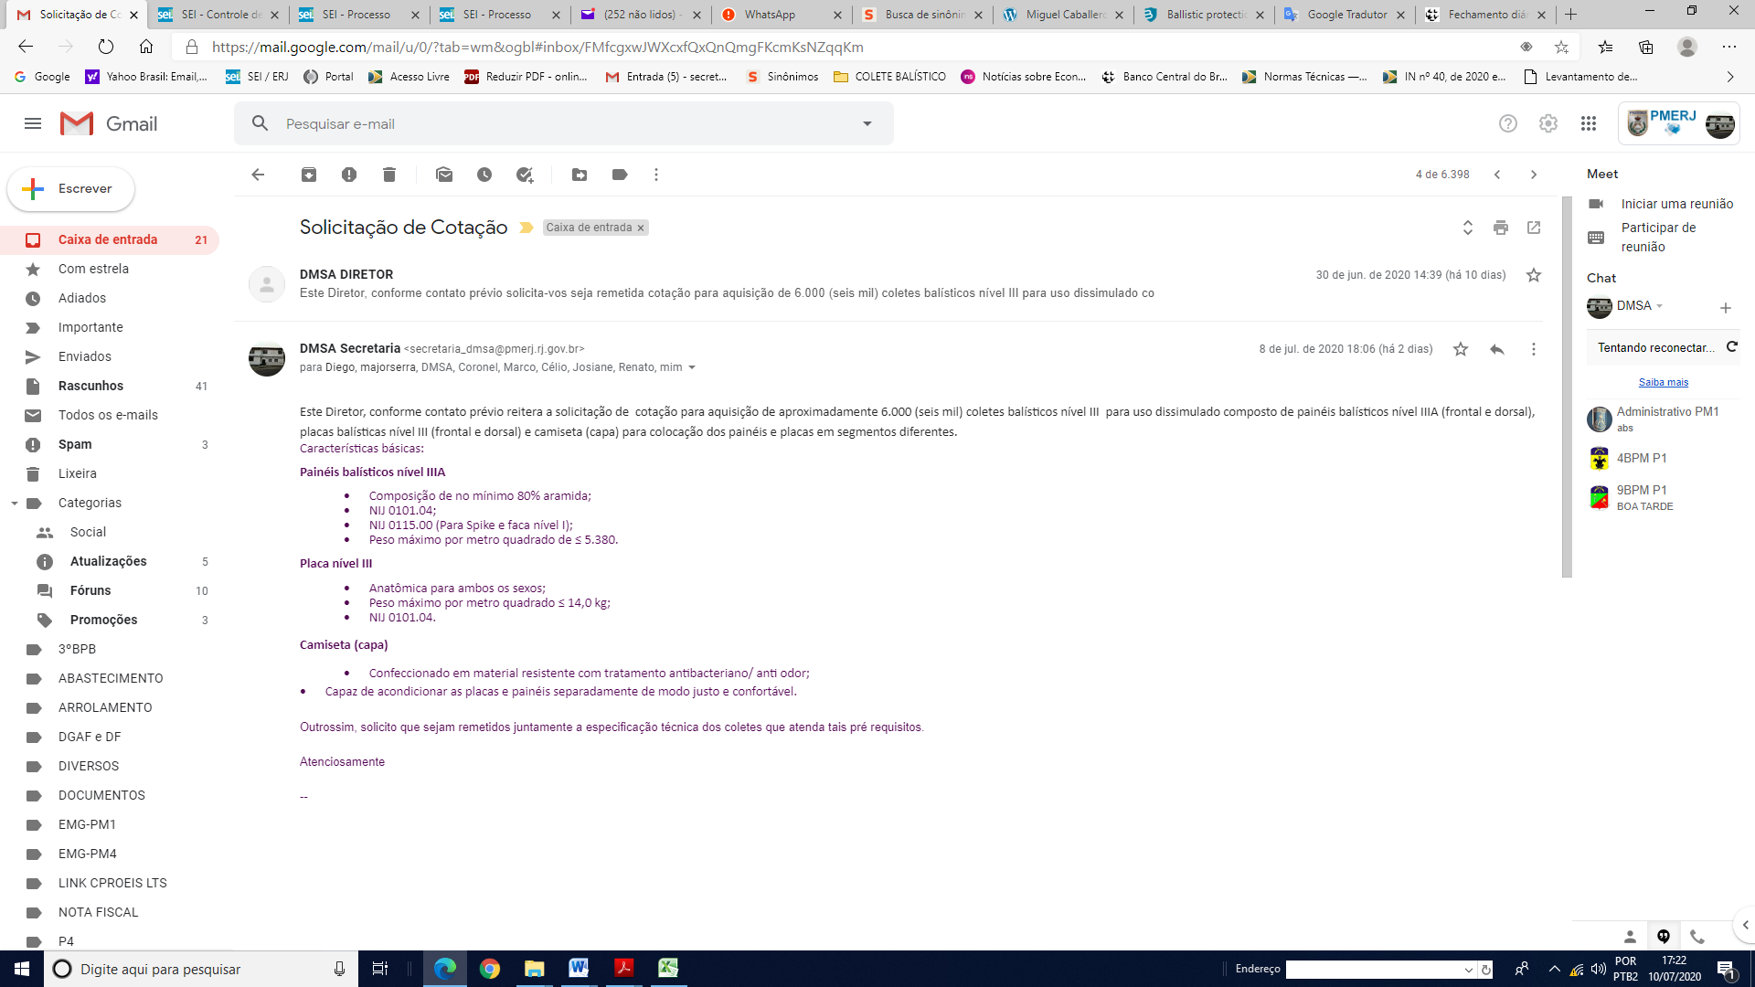

ANNEX II - Price proposal for the supply of the BONOWI International Police-Equipment GmbH Multi-Threat Ballistic Protection Vest.
ANNEX III - Commercial Proposal No. 3312 of TechScan Security and Intelligent Technology, representative of Miguel Caballero Attachment.

ANEXO IV - Proposta MKU Cotação Nº. : MKU/EXP/Q/2021/64.

